**FINAL PROJECT PROPOSAL**

Class: CS021

Students: Lucia Carrera, Simona Hřebcová

Professor: Jackie Horton

**DESCRIPTION OF THE FINAL PROJECT**

Our final project transfers an image to a text file that can be used to create flashcards (e.g. via Quizlet) and help students with their study.

**DATA REQUIREMENTS:**

1. INPUT: user’s image
2. OUTPUT: text file

**STEPS OF OUR PROGRAM:**

1. User uploads an image (view example below)

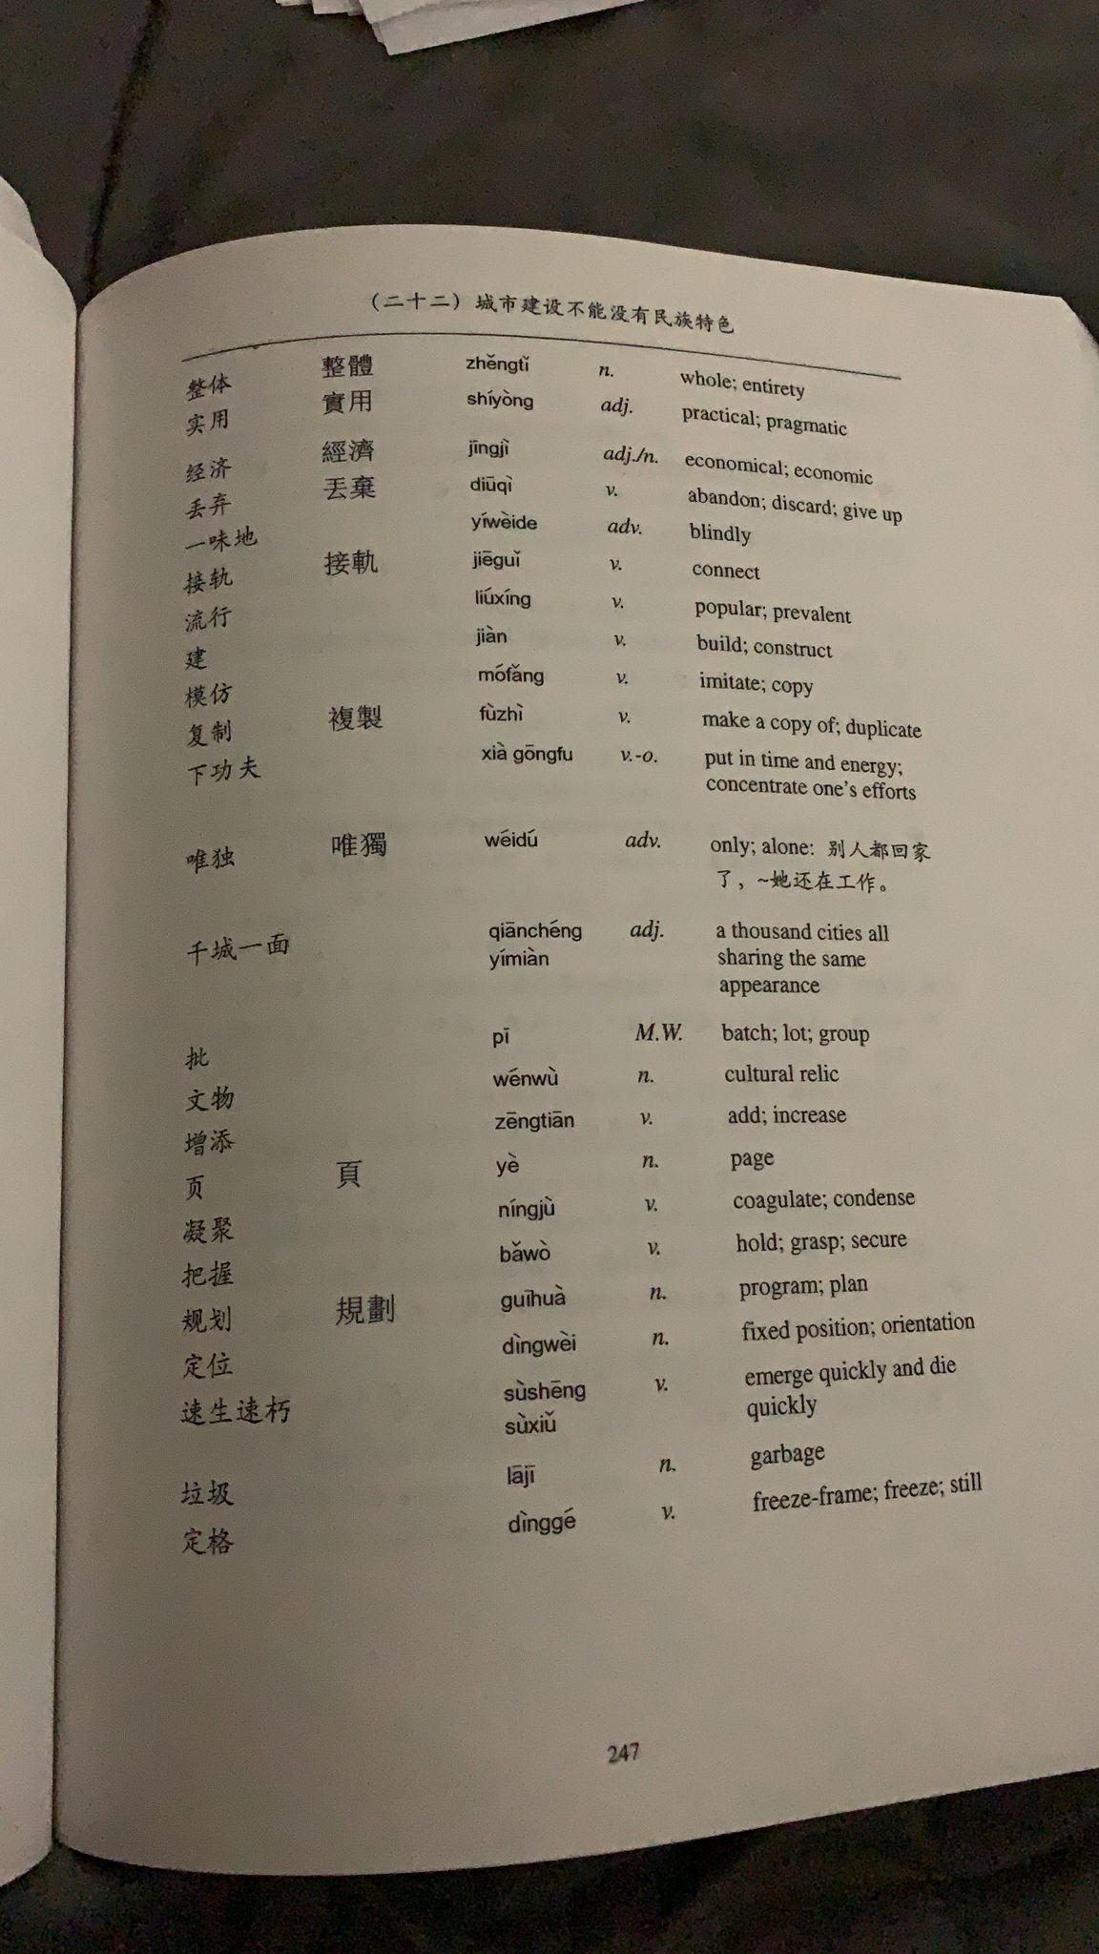

1. User selects an area of the image with vocabulary definitions
2. Program asks user if the vocabulary words are listed vertically or horizontally
3. Program recognizes whitespaces and shows it to user with headers
4. If there are more than 2 rows (horizontally) or more than 2 columns (vertically), ask user which rows/columns to include as term and which as definition. Multiple rows/columns can be chosen if so, user can choose how these will be separated.
5. Program recognizes text and creates an output file that can be uploaded to Quizlet.

**EXTRAS:**

* User can restart
* Add a new photo
* Choose outfile
* User can choose what rows/columns to include
* Recognize tables